Image result for children writing clipart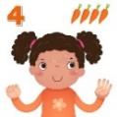[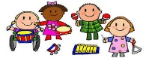](https://www.google.co.uk/url?sa=i&rct=j&q=&esrc=s&source=images&cd=&ved=2ahUKEwj80pSw0a_kAhXLzYUKHRXWCR4QjRx6BAgBEAQ&url=http%3A%2F%2Fclipartmag.com%2Fpreschool-centers-clipart&psig=AOvVaw30zQvOkXEytxns9NjXRv2U&ust=1567427705904707)[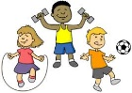](https://www.google.co.uk/url?sa=i&rct=j&q=&esrc=s&source=images&cd=&ved=2ahUKEwjIvuHY0K_kAhVHQBoKHf6eCosQjRx6BAgBEAQ&url=http%3A%2F%2Fclipart-library.com%2Fyouth-exercising-cliparts.html&psig=AOvVaw0FDByRGGT5n92YKwtE5L5C&ust=1567427488437358)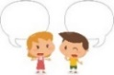Boy going to school from MyCuteGraphics | Free clip art, School images, Clip  art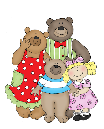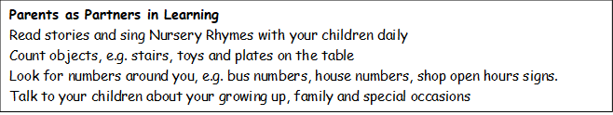 

**COMMUNICATION AND LANGUAGE**

Listen to a range of stories

Sit and listen attentively

Respond to simple instructions

Learn to retell the story of ‘Goldilocks and the Three Bears’ story using Talk for Write actions

Use longer sentences of 4 to 6 words in our circle times

**EXPRESSIVE ARTS AND DESIGN**

Role-Play House, Goldilocks and the Three Bears

Pastel self-portraits

Draw pictures of our families

Baby Bear collage

Explore names of musical instruments and listening to sounds they make

Learn ‘Goldilocks and the Three Bears song’

Move to music and explore the sounds instruments make

Colour collages

**UNDERSTANDING THE WORLD**

Name and describe people in their families

Talk about who lives in their house

Talk about birthdays and how old they are now

Learn about families through role-play

Plant Spring bulbs and find out how to care for growing plants



**MATHS**

Sing counting songs, e.g. ‘1,2,3,4,5 Once I Caught a Fish Alive’, ‘1 potato, 2 potato’, ‘5 speckled frogs’, ‘5 Little Ducks’, ‘5 currant buns’ and ‘5 fat sausages’

Count little people and match the correct numeral 1-3

Recite numbers past 5

Make a number line to 5

Count up to 3 on our fingers

Count up to 3 objects

Sort and match objects by colour, shape and size

**PHYSICAL DEVELOPMENT**

Throw and catch a ball

Developing balancing skills on obstacle courses and other equipment

Paint the windows using large paint brushes and rollers

Learn ‘the coat trick’

Wash hands properly

Dig our raised bed to prepare for planting

Snip paper with scissors, guide cutting of shapes

Use tweezers to pick up pom poms

**Key Vocabulary:** family, special, body, eyes, ears, nose, mouth, face, head, arm, leg, foot, hand, mummy, daddy, grandma, nana, grandad, uncle, aunty, cousin, baby, toddler, sad, happy, cross, tired, loud, soft, quiet.

**LITERACY**

Recognise and begin to learn to write our names

Share a range of stories about starting school

Share and learn the story ‘Goldilocks and the Three Bears’

Make meaningful marks using chunky chalk outdoors

Sing Nursery Rhymes

St Paul’s CE Primary School

**Nursery Knowledge Organiser**

Topic: Ourselves

Goldilocks and the Three Bears

**Autumn One**

**PSED**

Discuss classroom rules such as listen and kind hands and follow them

Learn to line up when coming in from playtime

Follow the daily routine using a timeline

Choose activities and resources with support

Take turns and share fairly

Play getting to know you circle time games