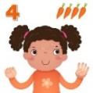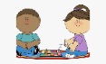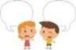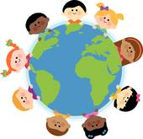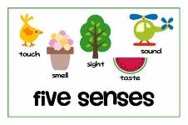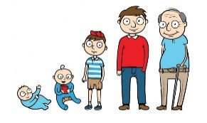[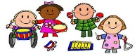](https://www.google.co.uk/url?sa=i&rct=j&q=&esrc=s&source=images&cd=&ved=2ahUKEwj80pSw0a_kAhXLzYUKHRXWCR4QjRx6BAgBEAQ&url=http%3A%2F%2Fclipartmag.com%2Fpreschool-centers-clipart&psig=AOvVaw30zQvOkXEytxns9NjXRv2U&ust=1567427705904707)[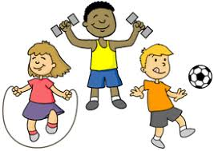](https://www.google.co.uk/url?sa=i&rct=j&q=&esrc=s&source=images&cd=&ved=2ahUKEwjIvuHY0K_kAhVHQBoKHf6eCosQjRx6BAgBEAQ&url=http%3A%2F%2Fclipart-library.com%2Fyouth-exercising-cliparts.html&psig=AOvVaw0FDByRGGT5n92YKwtE5L5C&ust=1567427488437358)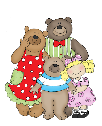Boy going to school from MyCuteGraphics | Free clip art, School images, Clip  art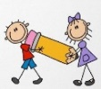 j 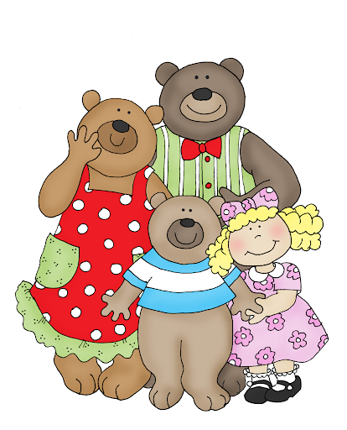 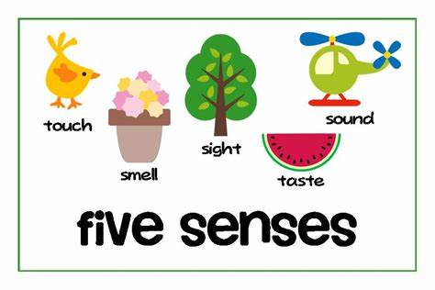

**LITERACY**

Write our names

Label pictures of our families

Join in with repeated refrains in the story

‘Goldilocks and the Three Bears ‘

Draw ‘Goldilocks and the Three Bears’ Story Mountains

Write a birthday card for the class puppet

Read and match labels to parts of the body

Label growing up pictures

Write a list of party foods

Begin to learn Phase 2 letter sounds in Phonics

Share stories about families

**MATHS**

*Match, sort and compare* amounts using buttons, socks and natural objects , use language more/fewer

*Compare size, mass and capacity* using teddies, boxes, small world animals use language full/empty, tallest, shortest, longest

*Explore repeating patterns* with colours, shapes, percussion

*Represent 1, 2, 3* with dots. Numicon 1 – 3 shapes, cube 1 – 3 towers, look, count, subitise, show on fingers Sort objects/pictures into groups of ‘1, 2 and 3’ Match numerals 1 to 3 to the correct quantity. Count to 5 and back, 10 and back Sing counting songs, e.g., ‘1,2,3,4,5’ once I caught a fish alive, ‘5 Little Ducks’’. Learn names and properties of simple 2D shapes

**Parents as Partners in Learning**  Read your child’s sharing book at betimes/quiet times. Discuss the characters and events and their favourite part of the story, encourage a love of books and reading. Engage with the weekly ‘Learning with Parents’ activities.

**Key Vocabulary:** family, past, present, old, new, community, friends, body, eyes, ears, nose, mouth, healthy, exercise, vitamins, iron, calcium, Doctor, Nurse, Dentist **Definitions:** The Human Life Cycle Baby, Toddler, Child, Adult, Elderly

Bb

BBb

**EXPRESSIVE ARTS AND DESIGN**

Role-Play House, Baby Clinic

Paint self-portraits and draw our families

Act out Goldilocks and the Three Bears

Explore steady beats, loud, soft, fast and slow sounds on the musical instruments and through movement

Painting to music

**PHYSICAL DEVELOPMENT**

Throw and catch a ball

Develop core muscles with ‘tummy time, activities

Develop good posture when sitting and standing

Use scissors effectively

Hold a pencil correctly

Do up a zip

Get dressed and undressed for PE independently

**UNDERSTANDING THE WORLD**

Name and describe people in our families

Talk about different types of families

Find out what happens in a Baby Clinic and how we grow from babies to adults..

Explore similarities and differences between birthdays and toys past and present Learn how to bake a Biscuit Bear

Find out how we make porridge? Where do oats come from? Taste porridge with fruit and/or honey.

Learn about our senses, describing what we see, feel, hear and smell on an Autumn walk

St Paul’s CE Primary School **Reception Knowledge Organiser Autumn One**

Topic: Ourselves/Autumn

Goldilocks and the Three Bears

**COMMUNICATION AND LANGUAGE**

Express ideas through well-formed sentences when talking about class rules, favourite toys and how to be a good friend

Use’ talk for writing’ actions to assist retelling of Goldilocks and the Three Bears using story vocabulary

**PSED**

Learn to see ourselves as valuable individuals, talk about their interests, their families

Build relationships with others in the class, share, take turns, listen to each other

Use story and talk to learn the importance of healthy eating, exercise, sleep, toothbrushing, and not too much ‘screen’ time.

Learn to manage our personal hygiene, wash hands before eating and after going to the toilet