Maths Autumn 2

. 1 more and 1 less

. Composition of 1,2 & 3

. Represent numbers 4 & 5

. Subitise 4 & 5

. Composition of 4 & 5

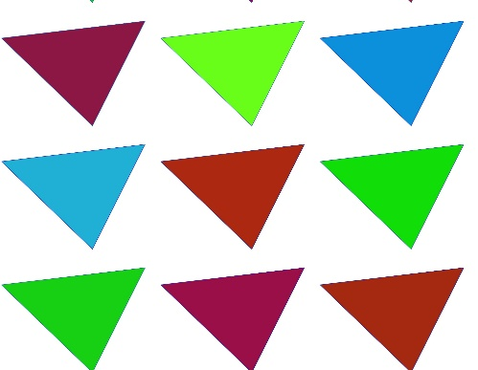

. Shapes in the environment

. Circles & triangles

. Identify and name shapes with 4 sides

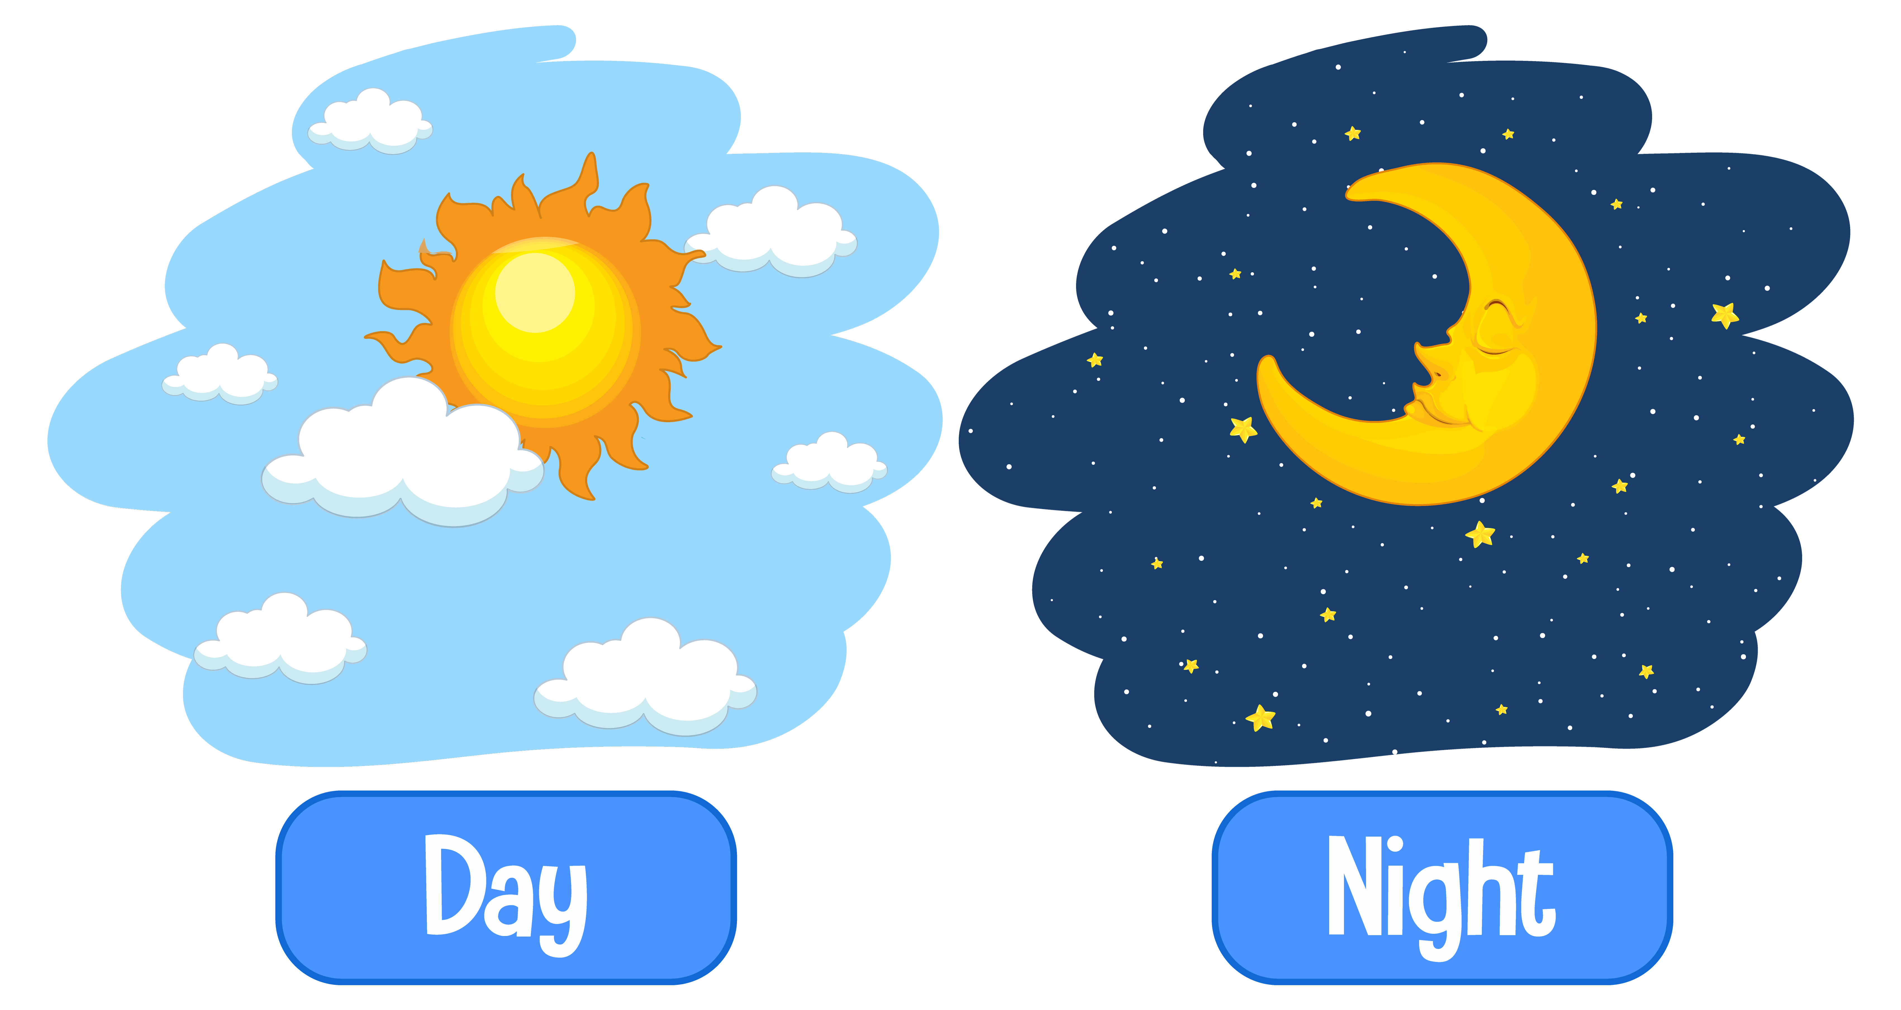. Describe position

. Day and night