<EMPTY>

**Vocabulary**

Chronology, timeline, Roman Empire, invasion, rebel,

Hadrian’s Wall, Boudica, resistance, enemy,

Romanisation, Britain, General, legacy, legionary,

primary and secondary sources of evidence

**Key Skills**

* Order timelines in chronological order
* Know the difference between primary and secondary sources of information.
* Ask questions and use primary and secondary sources to gather information.
* Use art to interpret primary and secondary sources of evidence.
* Use maps to study the size of the empire
* Look for connections, contrasts and trends with other known time periods.
* Use a range of historical words and phrases

**What I already know**

* There were life-style changes during different periods of history.
* How to order a simple timeline in chronological order.
* That sources of information help us to find out about the past.
* About changes in the daily life of people in my own life and from the past (Britain in 17th century, important people in the 20th century, Stone and Iron Age people ).

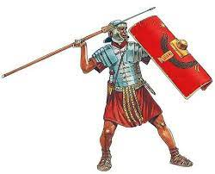

**New key learning**

* **How and when the Romans invaded Britain and that much of it became part of their empire**
* **That there was resistance to the Roman invasion**
* **The Roman army was extremely well organised and equipped**
* **Training and daily life of Roman soldiers**
* **The impact that the Roman army had on Britain and the legacy they left behind.**
* **What are the primary and secondary sources of evidence that tell us about the Romans?**

**St Paul’s CE Primary Knowledge Organiser Year Group: 3 Topic: What was it like to be a Roman Solider? Summer 1 Term: Spring 1**

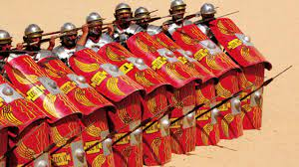

**Useful Websites** [**https://www.theschoolrun.com/homework-help/roman-empire**](https://www.theschoolrun.com/homework-help/roman-empire)[**http://www.primaryhomeworkhelp.co.uk/Romans.html**](http://www.primaryhomeworkhelp.co.uk/Romans.html)

https://www.historic-uk.com/HistoryMagazine/DestinationsUK/RomanSites/

**Parents as partners**

Draw or make a Roman shield or sandals. Research what Romans gave to Britain and make a list or draw and label them. Find out what Romans called London and other major British cities and towns. Visit a town or city in which the Romans once lived such as Chester.