|  |  |  |
| --- | --- | --- |
| Timeline | | |
| Neil Armstrong  1969 – moon landing by Americans | Mae Jemison  1992 – First black women in space. | Tim Peake  2015 – First British Astronaut in space. |

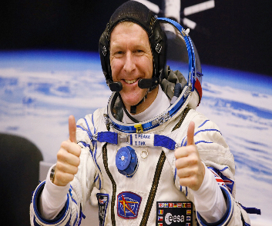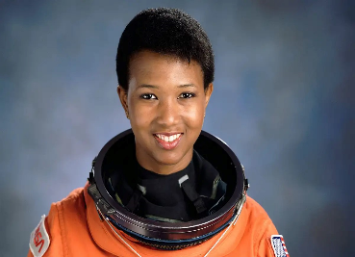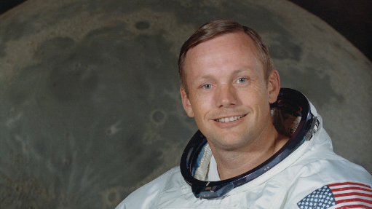

**Tim Peake** (1972-) the first British European Space Agency astronaut, the sixth

person born in the United Kingdom to go on board the International Space

Station and the seventh UK born person in space.

**Mae Jemison** (1956-) The first African American woman in space was Mae

Jemison. She lifted off in the space shuttle Endeavor on 12 September 1992.

**Neil Armstrong** (1930-2012) an American astronaut and aeronautical engineer,

who was the first person to walk on the Moon.

Key Questions

Vocabulary

**Astronaut** – a person who is trained to travel in space.

**Earth** – the planet where we live; the World.

**Moon** – a large, natural object that travels around (orbits) Earth, reflecting light from the sun.

**Lunar Module** – a small craft used to move between the moon’s surface and

orbiting spacecraft.

**Apollo 11** - the space vehicle that carried the astronauts to the first moon landing.

**Space** - the area that contains the entire universe beyond the earth.

**Significant Individuals**

Why was the Apollo 11 moon landing so important?

Why should we learn about Tim Peake?

Why should we learn about Mae Jemison?

Who was the first person to walk on the moon?

What makes astronauts significant people to learn about?

Could I go to Space?