Maths Spring 1

. 1 more and 1 less

. Composition of 0-5

. Represent numbers 6,7,8

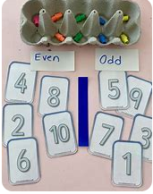

. Subitise 0-5

. Composition of 0-5

. Odd and even

. Compare mass

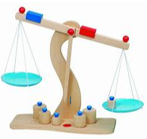

. Find a balance

. Explore capacity

. Compare capacity