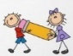[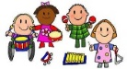](https://www.google.co.uk/url?sa=i&rct=j&q=&esrc=s&source=images&cd=&ved=2ahUKEwj80pSw0a_kAhXLzYUKHRXWCR4QjRx6BAgBEAQ&url=http://clipartmag.com/preschool-centers-clipart&psig=AOvVaw30zQvOkXEytxns9NjXRv2U&ust=1567427705904707)Image result for children sharing clipart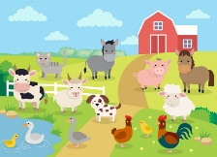

**LITERACY**

Continue to recognise our names.

To write some if not all the letters in our name

Share the story ‘The Little Red Hen’. Learn to retell the story orally using talk for writing actions.

Draw Little Red Hen Story Mountains

Paint pictures of farm animals and label

To take part in Phonics games

Follow planning from Little Wandle and introduce some initial sounds.

Listen to environmental sounds and rhyming games

Introduce sound talking, orally segmenting and blending sounds in words, for example, p-i-g and c-a-t.

**PSED**

Discuss ‘Forgiveness and Selfishness’ in circle times, linking to the story ‘The Little Red Hen’. Children talk about how to be helpful and why it is important to say ‘sorry’ if you do something wrong.

Children identify the characters who were selfish in the Little Red Hen.

Find out about food from farms.

Discuss what foods are good for us and keep our bodies healthy.

**EXPRESSIVE ARTS AND DESIGN**

Paint pictures of farm animals

Role-play – Little Red Hen / Farm shop

Make junk model farm animal

Create farm story scenarios when playing with the small world farm

Create a whole class ‘farm collage’

Sing and act out Nursery Rhymes about farm animals, e.g. Baa, baa black sheep, Mary had a little lamb, Little Bo Peep, Old MacDonald had a Farm, This little piggy went to market

**Nursery Knowledge Organiser Spring Two – Down on the Farm**

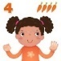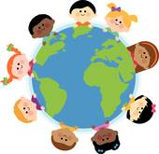[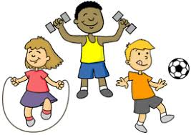](https://www.google.co.uk/url?sa=i&rct=j&q=&esrc=s&source=images&cd=&ved=2ahUKEwjIvuHY0K_kAhVHQBoKHf6eCosQjRx6BAgBEAQ&url=http://clipart-library.com/youth-exercising-cliparts.html&psig=AOvVaw0FDByRGGT5n92YKwtE5L5C&ust=1567427488437358)

**Key Vocabulary:** farm, barn, pens, pig, piglet, cow, calf, sheep, lamb, horse, foal, hen, chick, goat, kid, hay, corn, bake, vegetables, milk, bread, fruit, farmer, tractor

**MATHS**

Size order small world farm animals

Explore 2-D shapes - rectangle, square, circle and triangle

Consolidate our knowledge of numbers 0-6 through counting games and flashcards

Look at how tall we are and measure ourselves, who is the tallest? Who is the shortest?

Explore mass and capacity through games outdoors

**PHYSICAL DEVELOPMENT**

Cardboard weaving

Cut materials to make farm collages

Push the wheelbarrows in the garden

Dig in the garden

Use one-handed tools and equipment such as snipping paper with scissors

Continue to put their coat on and zip it up by themselves

**UNDERSTANDING THE WORLD**

Use information books, internet and powerpoints to find out about jobs and animals on a farm.

Watch the Cbeebies ‘Down on the Farm’ and play ‘A Year on the Farm’ and ‘Sounds on the Farm’ games.

Find out about food that comes from the Farm.

Plant potatoes, lettuce, kale, peas and nasturtiums in our garden.

Learn about the life cycle of a plant.

Discuss what plants need to help them grow.

Learn and match farm yard animals to the names of their babies.

**COMMUNICATION AND LANGUAGE**

Enjoy listening to longer stories and remember much of what happens

Orally learn the sounds farm animals make

Take part in circle times discussing why it is important to say ‘sorry’

Continue to speak in sentences of up to six words.

**Parents as Partners** Sing Nursery Rhymes and read stories about farms and farm animals Talk about the foods you buy, where they come from and name the vegetables. Print repeating patterns with potatoes



**Parents as Partners in Learning**

Please complete the Nursery Rhyme of the week homework and sing the nursery rhyme with your child. Read stories about farms together, e.g. Old MacDonald, Noisy Farm and Farmer Duck

At the shops, talk about the foods you buy and where they come from, name the fruits and vegetables.

Print patterns with potatoes

Help your child to learn the story, ‘The Little Red Hen’ using the story map ☺

Encourage your child to count their toys up to five, pointing to each one as they count out loud